**Query 1.**

**Show information for all surgery**

**SELECT p.pat_id,p.name,d.doc_id,d.name,pd2.disease,pd2.treatment**

**from doctor as d, pat_doc_2 as pd2 ,patient_1 as p**

**where d.doc_id = pd2.doc_id and p.pat_id = pd2.pat_id**

**and pd2.if_surge = 1**

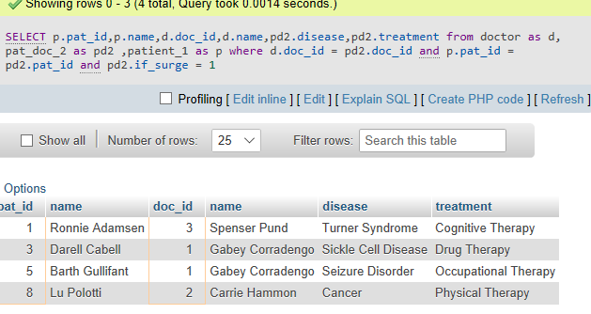

**Query 2.**

**Show all doctors’ information and departments’ names which is in contract.**

**SELECT d.doc_id,d.age,d.name,dd.dep_name**

**from doctor as d,doc_dep as dd**

**where d.doc_id = dd.doc_id AND if_contract = 1**

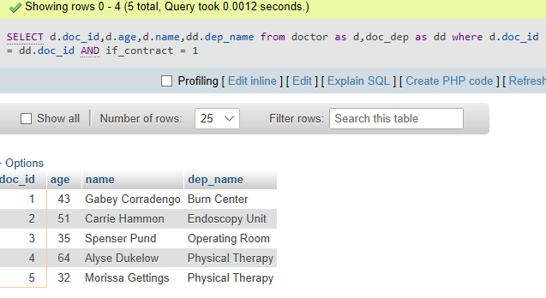

**Query 3**

**Show the visit date and treatment date for every patients**

**SELECT p1.pat_id,p1.name,p1.visit_date,pd1.date**

**FROM patient_1 as p1, pat_doc_1 as pd1**

**WHERE p1.pat_id = pd1.pat_id**

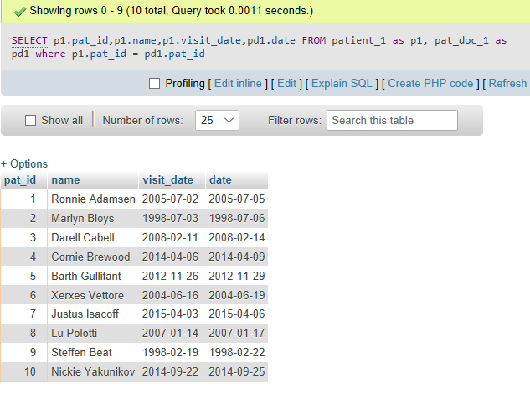

**Query 4**

**Show the day past from visit to treatment for every patients**

**SELECT p1.pat_id,p1.name,pd1.date-p1.visit_date**

**FROM patient_1 as p1, pat_doc_1 as pd1**

**WHERE p1.pat_id = pd1.pat_id**

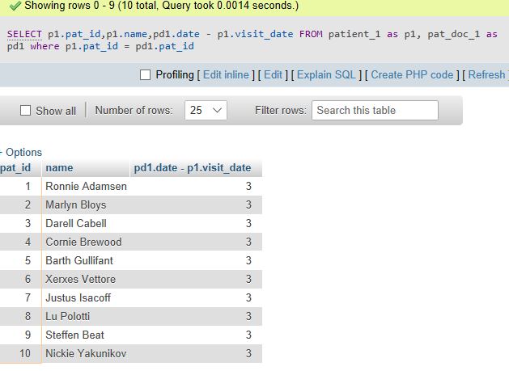

**Query 5**

**Show who is/are the doctors for all patients**

**SELECT p.pat_id,p.name,d.doc_id,d.name**

**from doctor as d, pat_doc_1 as pd1 ,patient_1 as p**

**where d.doc_id = pd1.doc_id and p.pat_id = pd1.pat_id**

**order by p.pat_id**

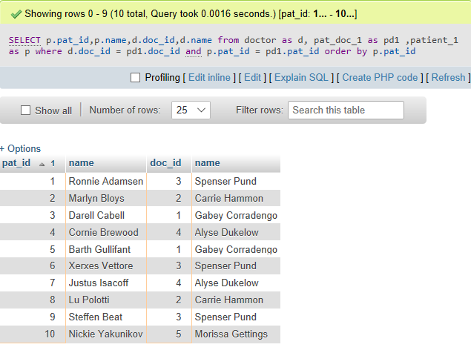

**Query 6**

**Find out how many doctors in each department and how many are in contract**

**SELECT \***

**FROM**

**(SELECT dep_name,COUNT(*)**

**FROM doc_dep**

**WHERE if_contract = 1**

**GROUP by dep_name) as tb1**

**INNER JOIN**

**(SELECT dep_name,COUNT(*)**

**FROM doc_dep**

**GROUP by dep_name) as tb2**

**on tb1.dep_name = tb2.dep_name**

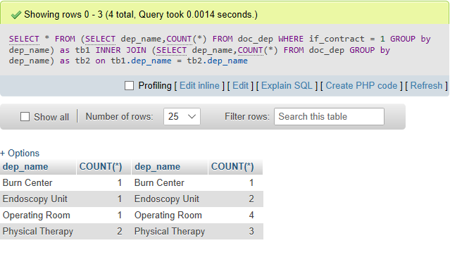

**Query 7**

**Show all inpatient’s information and the duration to stay**

**SELECT \***

**FROM patient_1 as p1, patient_2 as p2**

**WHERE p2.T =1 and p1.pat_id = p2.pat_id**

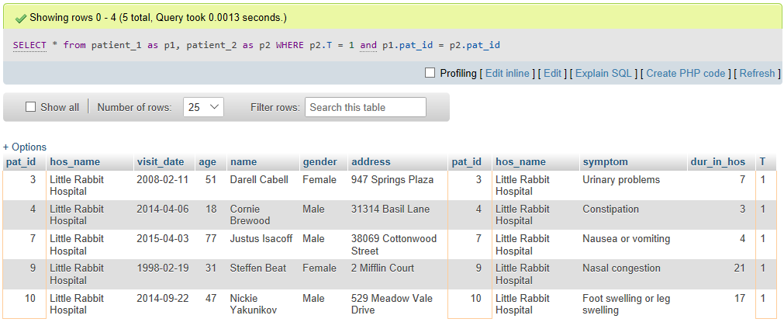

**Query 8**

**Show all outpatient’s information**

**SELECT \***

**FROM patient_1 as p1, patient_2 as p2**

**WHERE p2.T =0 and p1.pat_id = p2.pat_id**

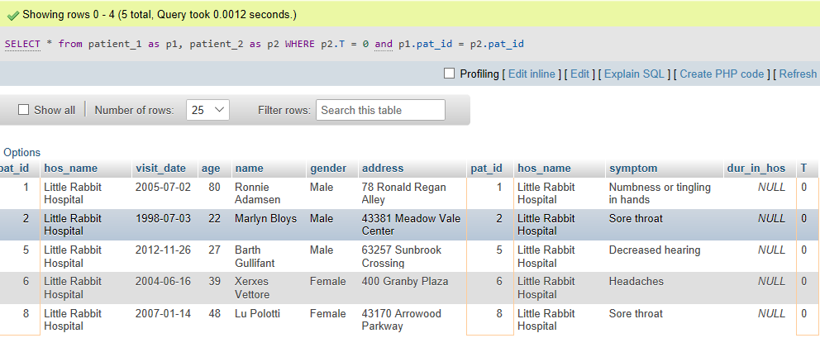

**Query 9**

**Show all diseases which are heal by treatment “Drug Therapy”**

**SELECT DISTINCT disease**

**FROM pat_doc_2**

**WHERE treatment = 'Drug Therapy'**

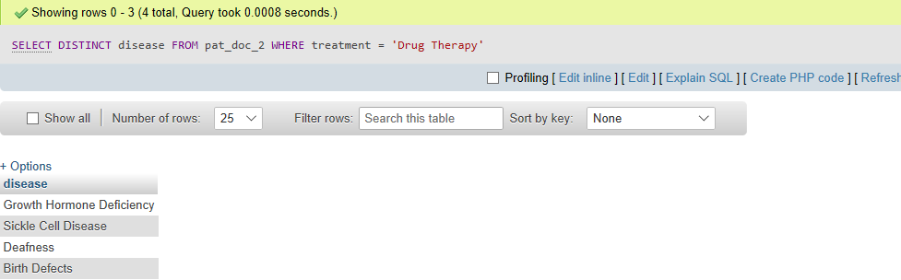

**Query 10**

**Show all patient’s symptoms and their disease**

**SELECT symptom,disease**

**FROM patient_2 as p2,pat_doc_2 as pd2**

**WHERE p2.pat_id= pd2.pat_id**

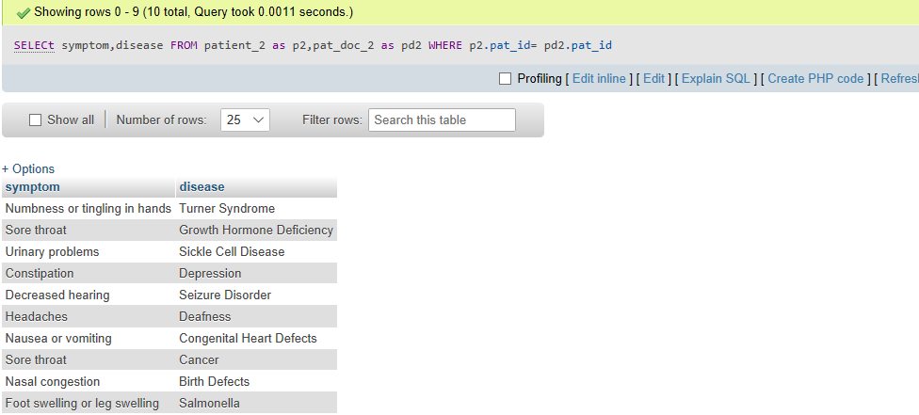

**INSERTION 1**

**INSERT INTO patient_1(pat_id,hos_name,name,age,gender,address,visit_date)**

**VALUES(NULL,(SELECT hos_name FROM hospital),'Cider Wong',24,'Female','412 Octagon Street',2018-04-02)**

**;**

**INSERT INTO patient_2(pat_id,hos_name,symptom,dur_in_hos,T)**

**VALUES(NULL,(SELECT hos_name FROM hospital),'Sleepy',NULL,0)**



<?php

// Connecting to database

$link = mysql_connect($wgScriptsDBServerIP, $wgScriptsDBServerUsername, $wgScriptsDBServerPassword, true);

if(!$link || !@mysql_SELECT_db($wgScriptsDBName, $link)) {

echo("Cant connect to server");

exit;

}

// Values to insert

$name = 'John Smith';

$weight = 83;

$height = 185;

// insertion to user table

$sql = "INSERT INTO user (name) VALUES ('$name')";

$result = mysql_query( $sql,$conn );

// retrieve last id

$user_id = mysql_insert_id( $conn );

mysql_free_result( $result );

// insertion to user_details table

$sql = "INSERT INTO user_details (id, weight, height) VALUES ($user_id, $weight, $height)";

$result = mysql_query( $sql,$conn );

mysql_free_result( $result );

?>